PASS WORD CREATION:
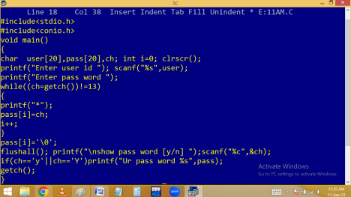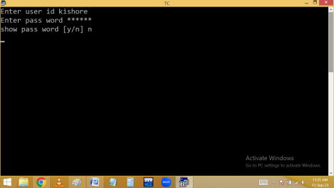
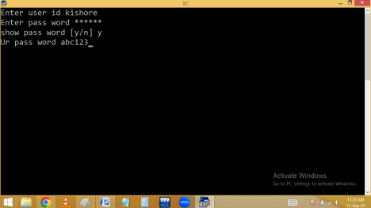Finding palindrome using single string:
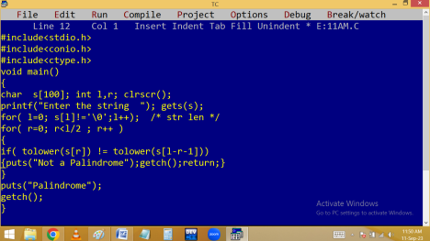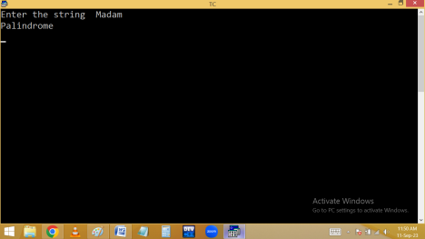
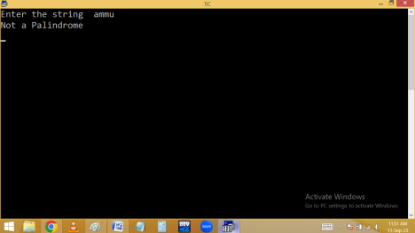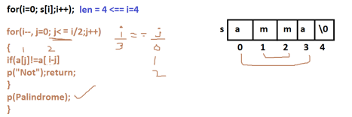
String library functions: To make string operation easy, the c language provides some predefined functions available in <string.h>. They are
1.strlen(): It return string length.
2.strrev(): return reverse string.
3.Strlwr(): return lower case string.
4.Strupr(): return upper case string.
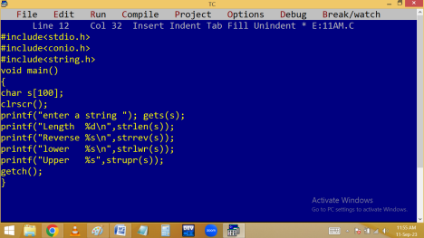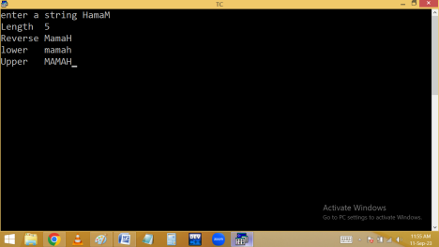
5.strcpy(): It copies the source string into destination string.
Strcpy(destination string, source string);
6.strncpy(): It copies specified no of char into destination string.
Strncpy(dest string, source str, no of char);
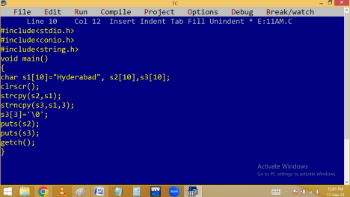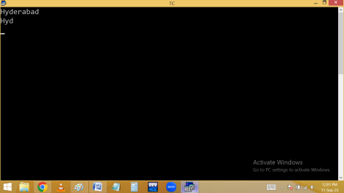7.strcat(): It adds string2 to string1.
Strcat(string1, string2);
8.strncat(): It adds specified no of char to string1.
Strncat(str1, str2, no of characters);
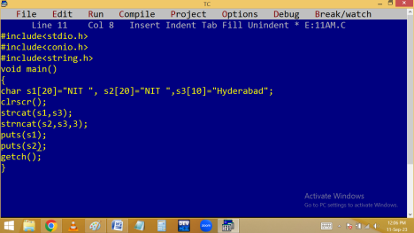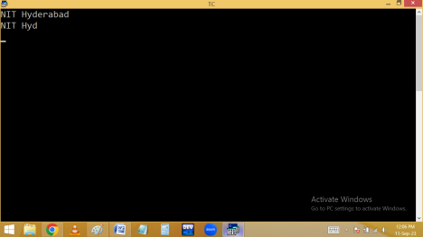
9.strcmp(): It compare string1 characters with string2 and return ASCII difference. When 1st difference occurred, the checking is stopped. Strcmp(string1, string2);
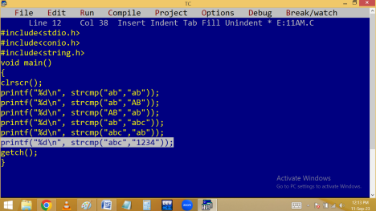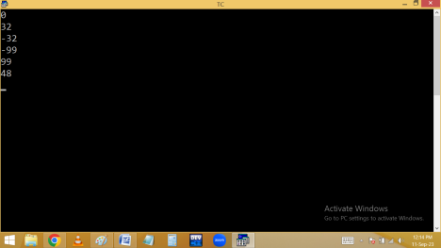10. stricmp(): It compare two strings by ignoring case. i.e. in stricmp() lower and upper are same. When matching letter not found or when
different data type found in 2nd string, the first string char taken in upper case.
11. strstr(): it searches the sub string position in main string and if found, it return the address of sub string.
strstr( main string, sub string );
Finding palindrome using library functions:
Sorting of strings using library functions:

